Core Concepts Covered
Docker Image Layers
Docker images are built in multiple read-only layers, where each layer corresponds to an instruction in the Dockerfile. These layers are immutable, meaning changes cannot be made directly to them. Instead, any modification requires building a new layer representing the delta (difference) from the previous layers.
  - Benefits include efficient storage, caching, and promotion of immutable images across environments, reinforcing the concept of immutable infrastructure.

Container Layer (Writable Layer)
When a container runs, Docker creates a writable container layer on top of the read-only image layers. Changes inside the container occur here, but this data persists only for the container’s lifetime. Once the container is removed, this writable layer and its changes are lost.

Persistent Storage with Volumes
To retain data beyond container lifecycle, Docker uses volumes, which store data independently on the host or external storage. Volumes enable data persistence even when containers are stopped or deleted.
  - Volumes are managed by volume drivers.
  - Data stored in volumes resides on the host filesystem (usually under /var/lib/docker/volumes on Linux) or can be stored on cloud storage or third-party providers.

Storage Drivers vs Volume Drivers
  - Storage drivers manage the layered filesystem of Docker images and containers, responsible for reading/writing data in container layers and creating image layers. Examples include overlay2 (most common for Linux), ZFS, VFS, AUFS (deprecated), and devicemapper (deprecated).
  - Volume drivers handle persistent storage and volume management; Docker defaults to the local volume driver for host storage but supports cloud and third-party drivers (like AWS EBS, Azure Files, Portworx).

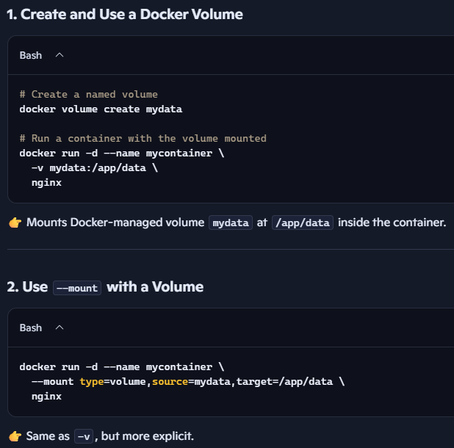
Mounting Volumes and Bind Mounts
  - Docker Volumes: Created and managed by Docker with the docker volume create command and mounted into containers using -v or --mount flags. Volumes abstract storage from the container and host filesystem, allowing easy portability and persistence. Stored under /var/lib/docker/volumes/. Decoupled from host filesystem structure.
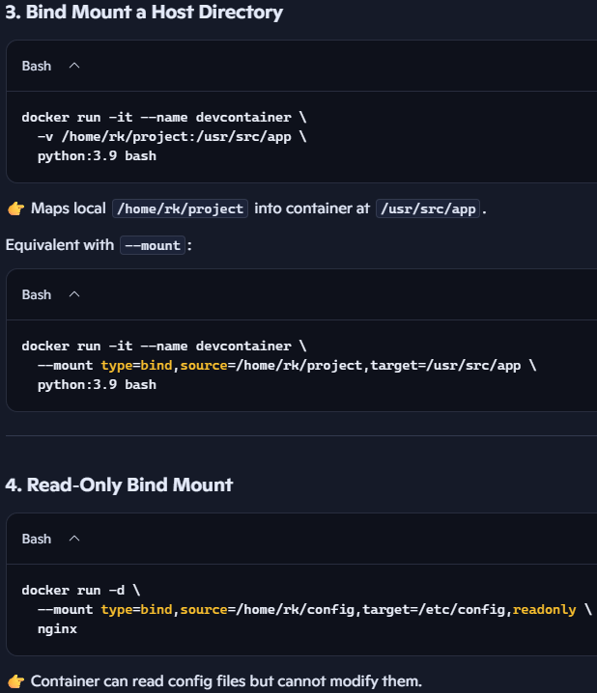
  - Bind Mounts: Bind a specific directory or file from the host filesystem directly into the container. This is done by specifying the host path and container path explicitly with the --mount type=bind option or -v flag. This allows direct access to host files but ties container storage tightly to the host environment.

Key Insights and Definitions
Term | Definition/Description
Read-only Layer | Immutable Docker image layer created from each Dockerfile instruction; cannot be modified once built.
Writable Container Layer | Layer created when a container runs; changes are saved here but lost when container is deleted.
Storage Driver | Manages Docker image and container file system layers (e.g., overlay2, ZFS, AUFS).
Volume Driver | Manages persistent storage volumes (e.g., local, cloud providers). Ensures data persists beyond container lifecycle.
Docker Volume | Storage abstraction created by Docker, stored on host or external storage, mounted inside containers for persistence.
Bind Mount | Directly mounts a host directory or file into a container path; tightly couples container storage to host.
Immutable Infrastructure | Concept where deployed images are immutable; updates require new images ensuring consistency across environments.

Practical Commands Highlighted
- Create volume:
sudo docker volume create data_volume
- List volumes:
sudo docker volume ls
- Run container with volume:
sudo docker run -d -p 3000:3000 -v data_volume:/app --name mycontainer myimage
- Run container with bind mount:
sudo docker run -d -p 3000:3000 --mount type=bind,source=/host/path,target=/container/path myimage
- Inspect volume storage location:
ls /var/lib/docker/volumes/data_volume/_data

Summary of Benefits and Use Cases
- Docker’s layered architecture optimizes image building and deployment by reusing cached layers and promoting immutability.
- Writable container layers allow runtime changes but are ephemeral.
- Docker volumes provide reliable persistent storage that decouples data from the container lifecycle.
- Bind mounts offer flexible direct access between host and container but reduce portability.
- Awareness of storage and volume drivers is crucial for optimizing storage performance and selecting appropriate persistent storage mechanisms, especially when migrating to Kubernetes.

